

RADIO CABS

Group 2 – C1012L – Bachkhoa-Aptech
Group Member | Name | Roll No
Group Member | Hoàng Minh Đường (leader)  Lê Việt Cường  Lưu Hữu Chuẩn  Nguyễn Trần Kiên | Student615110  Student481371  Student498040  Student496392
Falculty | Mr. Nguyễn Hồng Sơn

Ha Noi, 2013

Table of Contents

1. Problem Definition 4
1.1 Introduction: 4
1.2 Project Requirement 4
1.4 Hardware and Software Requirements 6
2. Customer Requirements Specification 7
2.1 Users of the System 7
2.2 System functions 7
3. Architecture & Design of the Project 11
3.1 Architecture 11
3.2 DFD 12
4. Entiy Relation Diagram (ERD) 17
5. Database 18
6. Algorithms 21
7. Snapshot 22
8. Task Sheet 23
9. Checklist of Validations 24
10. Submission Checklist 24

ACKNOWLEDGEMENT
We would like to acknowledge all those who have given support and help us make the project a success.
We wish to express our deep gratitude to all teachers who have been devoting their lives to teach us how to stand-alone and walk ahead.
We are grateful to our families who take care and encourage us even though we are successful or failed, also to our friends who are always care of us. They never leave us alone and always look forward to us when we are on any road of the life.
We are much thankful to the entire staff and chairmen at the Head Office of Aptech Worldwide, Aptech – Vietnam, and Bachkhoa – Aptech center who have been organizing and looking after our studying course.
Our special thanks to Mr. Nguyễn Hồng Sơn who works day by day to teach and guide us in our travel to discover the wonder of Java Programming Language. Also to mentor in eProject Team at the Head Office who instruct and help us.
Finally, we would like to offer many thanks to all our schoolfellows for their valuable suggestions.

We would like to thank sincerely!

Group 2 – C1012L

Problem Definition

Introduction:

We Radio Cabs is a complete website directory which provides information about Radio Taxi companies and their services in ABC (place) and all major cities of the country. With the assistance of this online Radio Taxi, you can effortlessly find all information you need about Radio Taxi Rental Services with their respective companies who serve you in ABC (place). RadioCabs.in with its city wise listing of best Radio Taxi operators helps you to indulge with best cab experience providing safe, cost effective and highly personalized world class transport, round-the-clock. It provides listing of Radio Cabs Company from all over India. RadioCabs.in is having 3 different type of Membership - Premium, Basic.

Project Requirement
Various Radio cabs company registers their account in this RadioCabs.in for advertising their company and attract the Client for using their services. For registering their account it should have a Registration form. There should be an information page for the user where it explains all kind of services provided by the organization. It also provides the listing of all the driver through out the country and company can find the driver according to their need. Company can even advertise about its organization through the advertise link provided by the site where they are supposed to register. Through advertisement company can enhance their business online.
For maintaining the information in the website in particular section the organization is supposed to pay to the RadioCabs.in through this website. Payment details must be stated in each registration page.
Payment can be done on two bases:
- Monthly
- Quarterly

 | Monthly | Quarterly
Registration | $ 15 | $ 40
Driver | $ 10 | $ 25
Advertisement | $ 15 | $ 40

There should be two logins:
- Admin login
- Registered Unit(like Listing, Driver, Advertise) login

ADMIN: Administrator will have the authority to maintain all the data of registration part like Radio cabs registration form, Driver Registration form, Advertising form, Feed Back. They will check the payment status of all the registration to maintain their information in the website. There should be separate page for the admin where he/she can view the entire data and update it accordingly. The link should be disabled for others irrespective of their logins.
REGISTERED UNIT: They can view their information and can also check the status like whether received any order. The payment status of the user should be on the display and the can pay their due amount online either monthly or quarterly.
USER: They can view the data and its services features. They can search the data of the Radio Cabs Company, Drivers. They can even provide the feed back and will be allowed to register in any section according to their needs.

- Functional Requirement
Home page: Here there should be an introduction part for explaining the purpose of the website. It should also contain all the menus like Listing, Drivers, Services, Advertise and Feed Back. One section of the page should be utilized for authentication purpose.

Listing page: This page should be designed with two sections:
- Registration where any user can register their Radio Cabs Company
- Where the register company and its details can be searched.
Registration part should contain following details like
      - Company Name
      - Company ID (should be check whether it is unique)
      - Password
      - Contact Person
      - Designation
      - Address
      - Mobile
      - Telephone
      - Fax Number
      - Email
      - Member ship type ( Premium, Basic, Free)
      - Payment Type (once selected then appropriate amount should be on display)

Drivers Page: This page should be designed with two sections:
      - Driver Registration page
      - Where the registered driver details can be searched.
Registration part should contain following details like
      - Driver Name
      - Driver ID (should be check whether it is unique)
      - Password
      - Contact Person
      - Address
      - City
      - Mobile
      - Telephone
      - Email
      - Experience
      - Description
      - Payment Type (once selected then appropriate amount should be on display)

Advertise page: This page is used for placing the order for advertising their Radio cabs organization.
It should contain following details like
      - Company Name
      - Designation
      - Address
      - Mobile
      - Telephone
      - Fax Number
      - Email
      - Description
      - Payment Type (once selected then appropriate amount should be on display)
FeedBack Page: This page is used to take the feed back from the user.
It should contain following details like
      - Name
      - Mobile No.
      - Email
      - City
      - Type (Complaint, Suggestion, Compliment)
      - Description
Note : there should two buttons i.e Submit Button and Reset Button in each Regisrtation page
Submit Button: For registering their inputs
Reset Button : To Reset the form.

Hardware and Software Requirements

 | Client | Server
Hardware | - CPU Pentium IV, 1.2 GHz (or better)  - 512 Megabytes of RAM (or better) | - CPU Pentium IV, 2.0 GHz (or better)  - 1024 Megabytes of RAM (or better)
Software | - Windows XP (or higher)  - IE7 / Firefox 4 or newer version | - SQL Server 2008  - JRE 7  - Apache Tomcat 7

Customer Requirements Specification

Users of the System
- Administrator
- Driver
- Company
- User

System functions

Admin:
- Login

Description | To allow the Administrator login.
Input | Email and password.
Process | Check email and password in database.
Output | Display the result login.

- Company Management

Description | Administrator can add, edit, delete, search company.
Input | Information of company.
Process | Insert, update , delete or search information into database.
Output | Display message box successful or display result on data table view.

- Driver Management

Description | Administrator can add, edit, delete, search driver .
Input | Information of driver.
Process | Insert, update ,delete or search information into database.
Output | Display message box unsuccessful or display on data table view.

- Advertise Management

Description | Administrators can add, edit, delete, search and view advertise.
Input | Information of advertise.
Process | Insert,search, update or delete information into database.
Output | Display message box successful or display result on data table view.

- Payment Management.

Description | Administrator can add, edit, delete, search and view employee.
Input | Information of employee.
Process | Insert, update,delete or search information into database.
Output | Display message box unsuccessful or display on data table view.

- Feedback Management.

Description | Administrator can edit, delete, search and view feedback.
Input | Information of feedback.
Process | Insert, update,delete or search information into database.
Output | Display message box unsuccessful or display on data table view.

- Administrator Management.

Description | Administrator who has role higher , can add, edit, delete, search and view administrators ,who have role lower .
Input | Information of administrator.
Process | Insert, update,delete or search information into database.
Output | Display message box unsuccessful or display on data table view.

Driver/Company:
- Login

Description | To allow driver/company login.
Input | RegistrationID and password.
Process | Check registrationID and password in database.
Output | Display the result login.

- View information

Description | View information
Input | Account of driver/company
Process | Load information
Output | Display information

- Payment

Description | To allow driver/company to pay online
Input | Payment Information
Process | Insert payment into database.
Output | Display message box successful or unsuccessful.

- User

- Search Driver

Description | Search Drivers
Input | Information of Driver
Process | Search drivers in database.
Output | Display all candiate drivers.

- Search Company

Description | Search Companies
Input | Information of Company
Process | Search companies in database.
Output | Display all candidate companies.

- Advertise

Description | To allow user to post advertise
Input | Advertise Information
Process | Insert advertise and payment into database.
Output | Display message box successful or unsuccessful.

- Feedback

Description | To allow user to take feedback
Input | Feedback Information
Process | Insert feedback into database.
Output | Display message box successful or unsuccessful.

- Register

Description | To allow user to register
Input | Register Information
Process | Insert regiter information into database.
Output | Display message box successful or unsuccessful.

Architecture & Design of the Project

Architecture

Web-Tier

Middle-Tier

User interface with JSF pages

Managed Bean containing business logic

SQL Server 2008

Database-Tier

Web-Based Distributed 3-Tier Architecture of the Project

DFD

    - Level 0

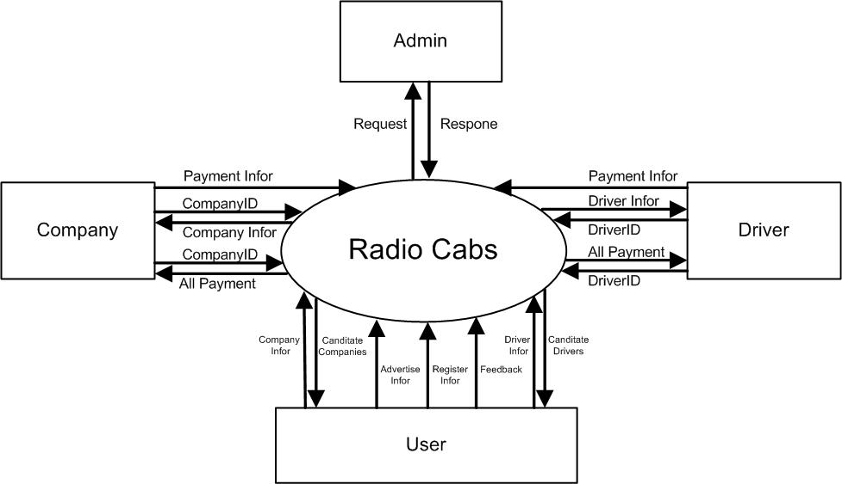

DFD Level 0

    - Level 1

      - User

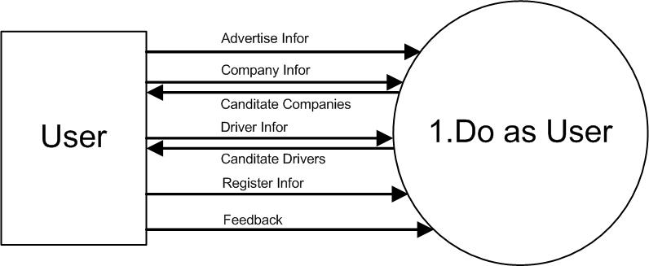

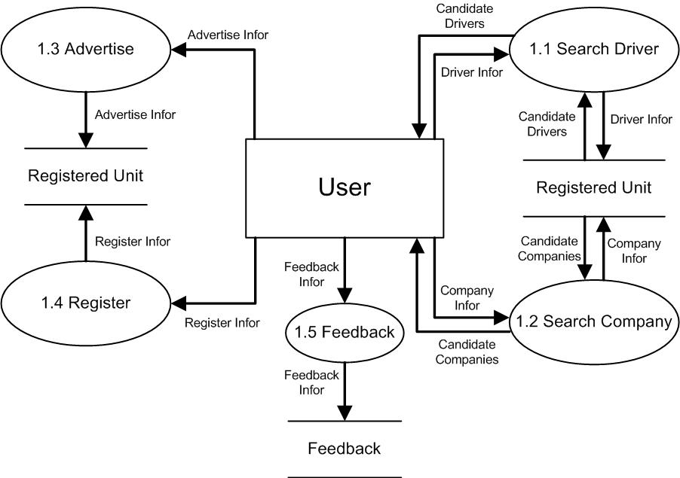

User DFD Level 1

      - Driver

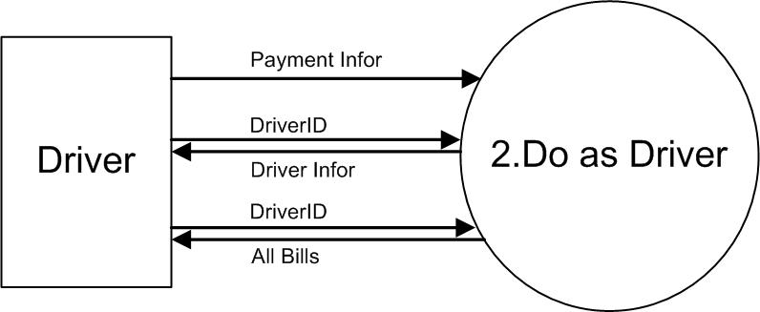

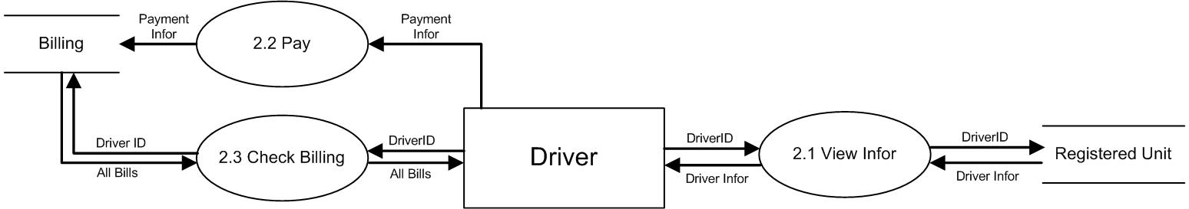

Driver DFD Level 1

      - Company

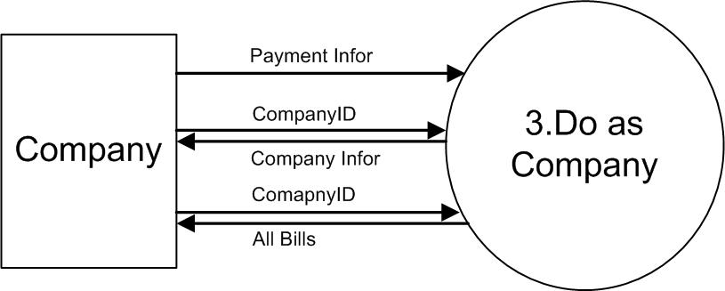

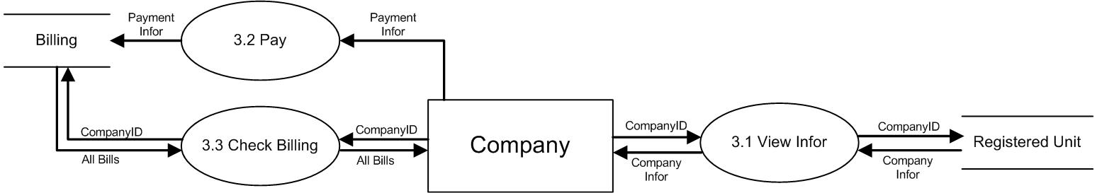

Company DFD Level 1

      - Admin

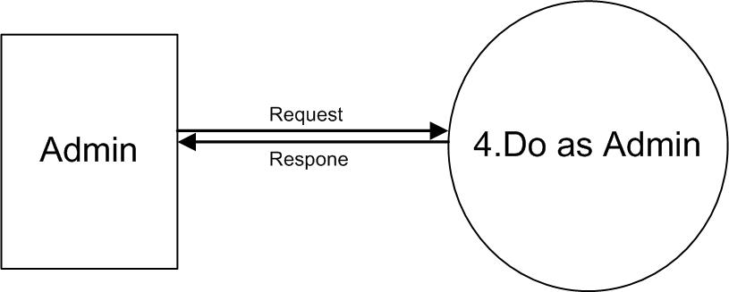

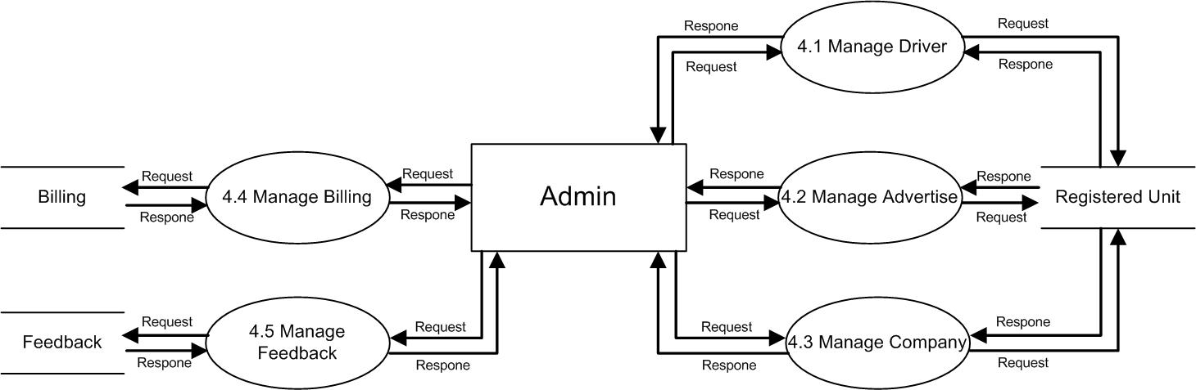

Admin DFD Level 1

- ERD

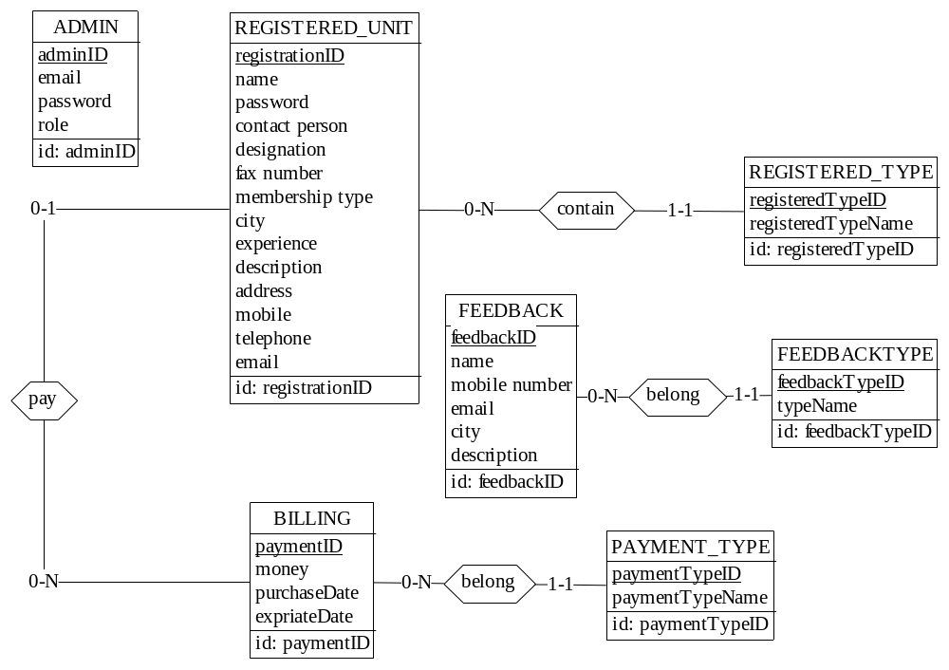

Radio Cabs Entity Relation Diagram

- Database Design

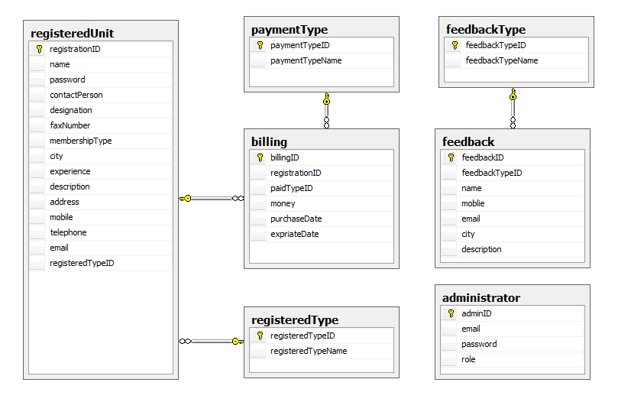

RegisteredUnit
Fields | Data Type | Is Null | References | Description
registrationID | varchar(10) | No | Primary Key | Registration ID
name | varchar(200) | No |  | Fullname
password | varchar(50) | Yes |  | Password
contactPerson | varchar(200) | Yes |  | Person to Contact
designation | varchar(100) | Yes |  | Designation in company
faxNumber | varchar(20) | Yes |  | Fax number
membershipType | int | Yes |  | Type of membership (Premium, Basic, Free)
city | varchar(100) | Yes |  | City
experience | int | Yes |  | Experience (year)
description | varchar(200) | Yes |  | Description
address | varchar(200) | Yes |  | Address
mobile | varchar(20) | Yes |  | Mobile number
telephone | varchar(20) | Yes |  | Telephone number
email | varchar(100) | Yes |  | Email
registeredTypeID | int | No | Foreign Key | Type of registered User (company, driver, advertise)

RegisteredType
Fields | Data Type | Is Null | References | Description
registeredTypeID | Int(identity) | No | Primary Key | Registered type ID
registeredTypeName | varchar(200) | No |  | Register type name (Driver, Company, Advertise)

Feedback
Fields | Data Type | Is Null | References | Description
feedbackID | int | No | Primary Key | Feedback ID
feedbackTypeID | int | No | Foreign Key | Feedback Type (Complaint, Suggestion, Compliment)
name | varchar(200) | No |  | Fullname of user send feedback
mobile | varchar(20) | Yes |  | User Mobile
email | varchar(100) | Yes |  | Email
city | varchar(100) | Yes |  | City
description | varchar(200) | Yes |  | Description

Feedback Type
Fields | Data Type | Is Null | References | Description
feedbackTypeID | Int(identity) | No | Primary Key | Feedback Type ID
feedbackTypeName | varchar(100) | No |  | Feedback Type Name (Complaint, Suggestion, Compliment)

Billing
Fields | Data Type | Is Null | References | Description
billingID | int | No | Primary Key | Billing ID
registrationID | varchar(10) | No | Foreign Key | Registration ID
paidTypeID | int | No |  | Paid Type (monthly, quartly)
money | float | No |  | Money
purchaseDate | date | Yes |  | Purchase Date
expriateDate | date | Yes |  | Expriate Date

PaymentType
Fields | Data Type | Is Null | References | Description
paymentTypeID | int | No | Primary Key | Payment Type ID
paymentTypeName | varchar(100) | No |  | Payment Type Name (monthly, quartly)

Admin
Fields | Data Type | Is Null | References | Description
id | Int(identity) | No | Primary Key | ID of Admin
email | Varchar(100) | No |  | Email
role | Int | No |  | Role of Admin
password | Varchar(100) | No |  | Password of Admin

Algorithms

Flow chart 1: Login

Begin
Input user name and password
End
Try again?
False
Yes
No
User exists and password match

Access application

Flow chart 2: Add new a record

Begin

Input fields

False
Validate data

Save to database

Message
End

Flow chart 3: Update a record

Begin

Input data

False
Validate data

Save to database

Message
End

Flow chart 4: Delete a record

Begin
Choose record to delete
False
Validate data

Save to database

Message
End

Flow chart 5: Search a record

Begin
Input data to search
False
Validate
Display result
End
Try again?
No
Yes

- Snapshot

  - Snapshot Admin

- Login page

- Admin page (like Company Mangament page)

- Administrator Management Page

- Driver Management Page

- Advertise Management Page

- Feedback Management Page

- Billing Management Page

  - Snapshot Client

Task Sheet

Project Ref.No.: |  | Project Title | Active Plan Prepared By: | Date Of Preparation Of Activity Plan:
Sr.No | Task | Project Title | Active Plan Prepared By: | Actual Start  Date | Actual  Days |  | Team Member  Name | Status
Document & GUI
1 | Analyze System | Radio Cabs | Group 2 | 02/11/2013 | 2 day | Group |  | Completed
2 | Design Database | Radio Cabs | Group 2 | 04/11/2013 | 2 days | Hoang Minh Duong |  | Completed
3 | Report | Radio Cabs | Group 2 | 6/11/2013 | 2 days | Group |  | Completed
4 | GUI Admin | Radio Cabs | Group 2 | 08/11/2013 | 2 days | Luu Huu Chuan  Nguyen Tran Kien |  | Completed
5 | GUI Client | Radio Cabs | Group 2 | 08/11/2013 | 3 days | Le Viet Cuong  Hoang Minh Duong |  | Completed
Coding
6 | Client Driver | Rado Cabs | Group 2 | 11/11/2013 | 2 days | Hoang Minh Duong  Le Viet Cuong |  | Completed
7 | Client Advertise | Rado Cabs | Group 2 | 20/09/2013 | 3 days | Hoang Minh Duong |  | Completed
8 | Client Company | Rado Cabs | Group 2 | 20/09/2013 | 1 day | Le Viet Cuong  Hoang Minh Duong |  | Completed
9 | Location Management | Rado Cabs | Group 2 | 20/09/2013 | 1 day | Nguyen Van Huy |  | Completed
10 | Project Management | Rado Cabs | Group 2 | 24/09/2013 | 1 day | Nguyen Van Luu  Vu Hoang |  | Completed
11 | Account Management | Rado Cabs | Group 2 | 25/09/2013 | 1 day | Nguyen Van Luu |  | Completed
12 | Employee Request | Rado Cabs | Group 2 | 26/09/2013 | 1 day | Hoang Minh Duong |  | Completed
13 | Employee Detail |  | Group 2 | 26/09/2013 | 1 day | Nguyen Van Huy |  | Completed

Checklist of Validations

Option | Validated
Can a new user who gets registered, enter the application after logged in? | Yes
Do all the options present in the application display the correct result? | Yes
Does the application’s functionality resolve the user problem, and satisfy their needs? | Yes
Has the hardware and software been correctly chosen? | Yes

Submission Checklist

Sr.No | Particular | Yes | No | NA | Comment
1 | Are you users able to login to the application after validation is performed on the user name and password? | Yes
2 | Are the users able to modify their details after getting registered? | Yes
3 | Are all the screen contents devoid of spelling mistakes? | Yes
4 | Is the user able to trade on fund which has been selected? | Yes
5 | Is the application user-friendly? | Yes

